This system consists of 5 roles: System Admin, Community Admin, Hospital Admin, Doctors and Patients.

System admin will have the provision to perform CRUD operations on Community, Hospitals, Person, Doctor, Patient and Encounters.

Community admin can perform the CRU operation on City, Community and House .

Hospital admin links hospitals to Community and City. Also manages Patients, doctors and encounters

Doctors manages the patient’s encounter history as well as vital signs for the encounter

Patient views his/her information , can lookout for the hospitals and doctors, access and edit his/her personal and encounter information.

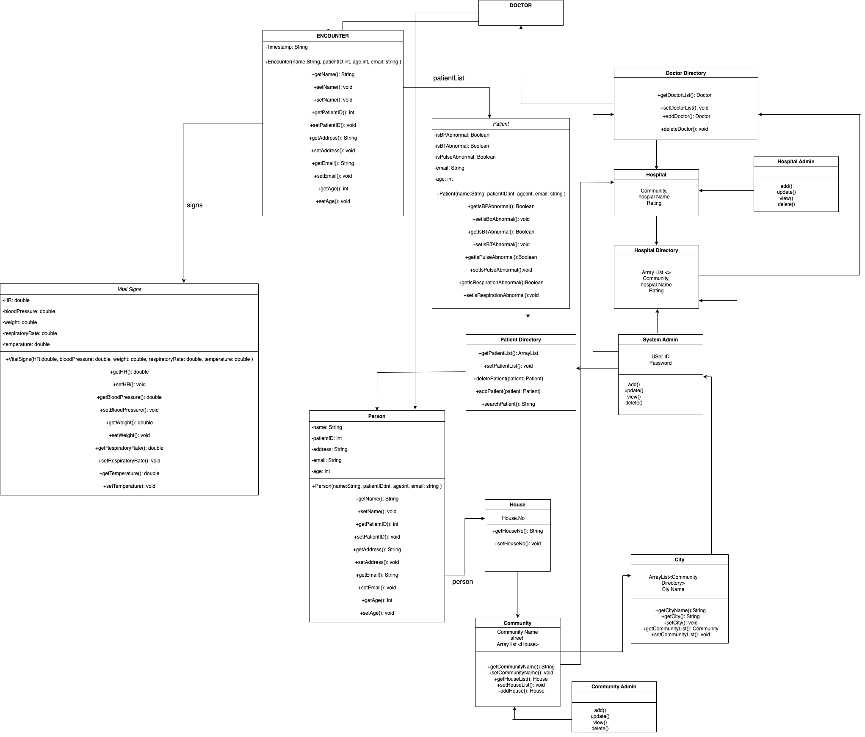

Class diagram

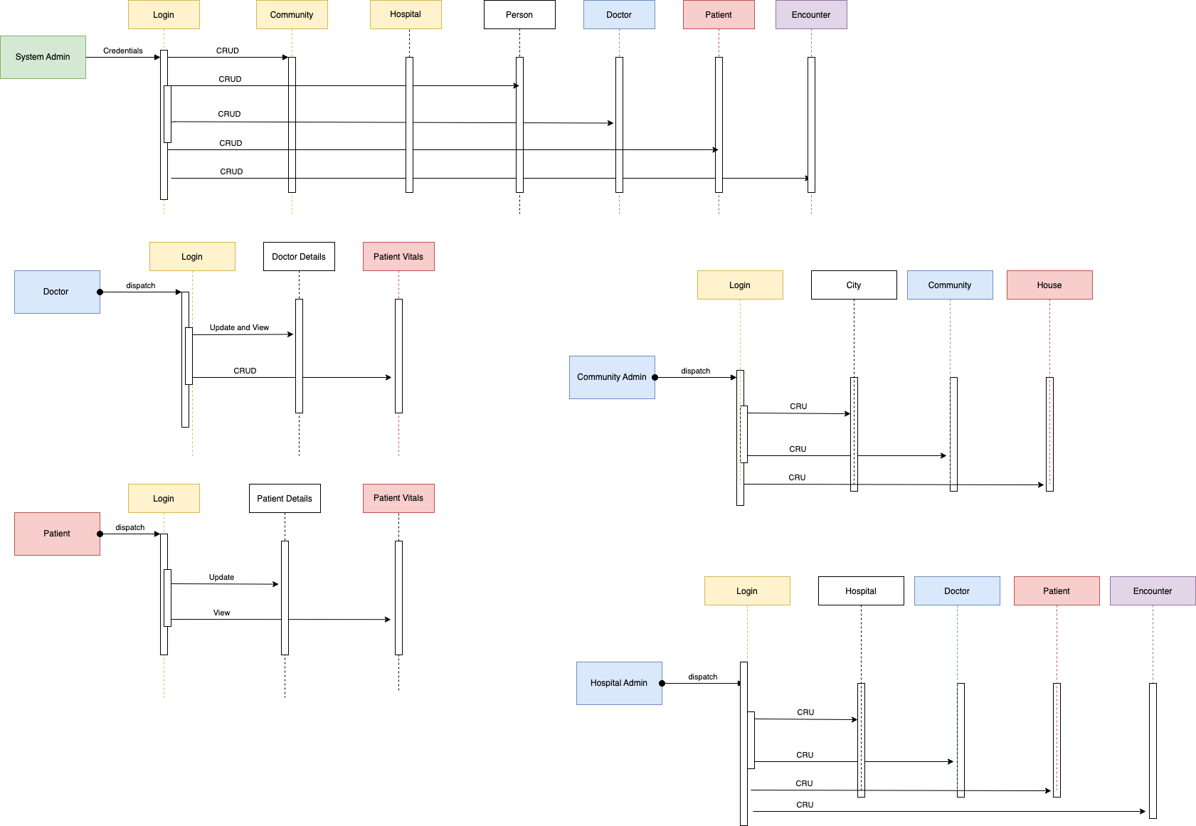

Sequence diagram